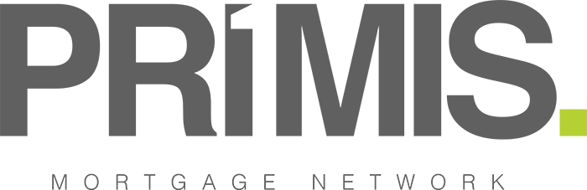

15th December 2020

PRIMIS records over 13,000 attendees at virtual workshops since the start of Covid-19
- PRIMIS has held a total of 265 training workshops since 23rd March 2020 – more than double the number that were held in 2019
- Highest levels of attendee engagement were seen at PRIMIS’ ‘Protection Excellence’ and ‘One Step, One Leap’ workshops
- Meanwhile, the network’s product desk received 24% more queries from brokers between April – November compared to pre-coronavirus figures

PRIMIS Mortgage Network has today revealed that a total of 13,103 broker members and staff have attended its virtual workshops since 23rd March 2020. The network has held a total of 265 workshops between this date and December 2020, covering a variety of areas including protection, general insurance (GI), technology, social media, and others. This is more than double the number of workshops that were held by PRIMIS in 2019.

The greatest levels of attendee engagement were seen at PRIMIS’ ‘Protection Excellence’ and ‘One Step, One Leap’ workshops, with these sessions attracting 4,231 attendees in total. This accounts for almost a third (32%) of the total attendee figure for all sessions held since 23rd March. The network’s ‘Protection Excellence’ workshops support brokers looking to enhance their skillset in the area of protection, with the most popular session among advisers focused on how to ensure effective fact-finding.

Meanwhile, PRIMIS’ ‘One Step, One Leap’ virtual events draw on industry insight, educating brokers on the relevant sales skills and inspiring them to bolster their business.

Additional sessions that were popular among PRIMIS members and staff included its workshops on ‘Selling to an Existing Client Bank’, which attracted 646 attendees, and its Social Media Masterclasses, which saw 678 members of staff and advisers attend in total.

Vikki Jefferies, Proposition Director at PRIMIS, comments: “During these uncertain times, PRIMIS has prioritised support for broker firms to ensure that they are well-equipped to help a variety of borrowers with their financial needs. Moving all our workshops online has been no mean feat, and we are proud that the sessions have been met with great reception from the wider network. It has been really encouraging to see such a high level of engagement for our workshops since the start of the coronavirus crisis, with more advisers and staff attending now than in previous years and many asking that we continue these sessions on a virtual basis going forwards. Sharing best practice is at the heart of the network, and we hope that our workshops help attendees feel more confident and knowledgeable on how to excel in this market.”

Moreover, the network’s product desk – which assists brokers nationwide with a variety of queries regarding mortgages, protection, GI, and digital systems – has received 16,948 queries from brokers between April – November. This marks a 24% increase on the average number of queries the desk typically receives from advisers in any given eight-month period during ‘normal’ market conditions (13,616).

The product desk team is currently operating an email and call-back only service while Covid–19 restrictions remain in place and aims to resolve queries from advisers within four hours. This compares to a 24 hour average turnaround time during pre-pandemic conditions.

Vikki Jefferies concludes: “The work of our product desk has been crucial to ensuring that brokers have been able to continue delivering a high level of service to clients during Covid-19. The product desk team has been working incredibly hard to help brokers with their queries amid the uncertainty surrounding the pandemic, and it is great to see that this has been a resource that our members have made the most of. We are confident that firms will continue to take advantage of the team’s expertise in order to secure positive outcomes for clients.”

-ENDS-

For further information please contact:
Name: Eve Frayling
Telephone: 07827 995 180
E-mail: e.frayling@rostrum.agency

Notes to Editors
About PRIMIS Mortgage Network
PRIMIS Mortgage Network brings the power of First Complete Ltd, Advance Mortgage Funding Limited and Personal Touch Financial Services Ltd together under one roof so we can provide you with world class support that is second to none. We are part of the LSL Group and backed by their extensive financial services experience and knowledge we aim to grow not just our Network, but your business as well.

